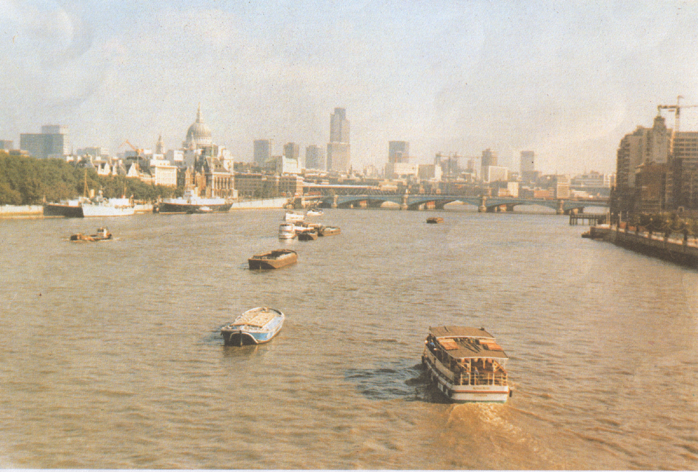
“A Trip around the United Kingdom of Great Britain and
Northern Ireland”.

Objectives: to improve pupils’ speaking, reading, listening, writing skills; to revise the Past Perfect Tense.
Equipment: a map of the United Kingdom of Great Britain and Northern Ireland, a computer, pictures of the places of interest of the UK, posters, and handouts.

Procedure.

The Plan of the Lesson.
- The geographical position of the U.K.
- England, Scotland, Wales and Northern Ireland.
- London, the capital of the country.
- Places of interest of London.
- Outstanding people of the country. William Shakespeare.
- The summary of the lesson.

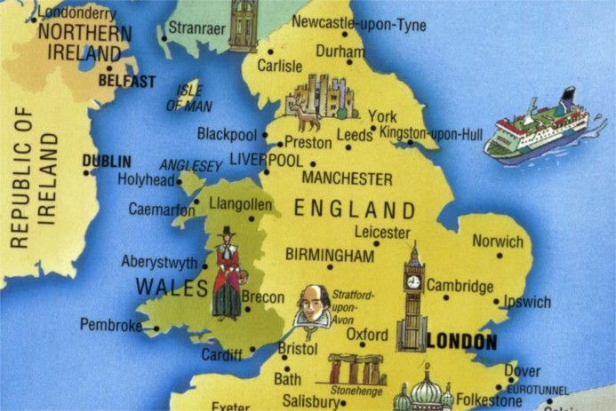
Teacher: Today we are going to speak about the country we usually call England. But what is the full name of this country? The full name of this country is the United Kingdom of Great Britain and Northern Ireland. And I want to tell you about this country. The United Kingdom of Great Britain and Northern Ireland is situated on the British Isles. It consists of four countries: England, Scotland, Wales and Northern Ireland. You can see them on the map. Their capitals are London, Edinburgh, Cardiff and Belfast.
The area of the country is 244,000 sq. km. The population of the country is about 57 mln.people.
The U.K. is separated from the continent by the English Channel. It is washed by the Atlantic Ocean, the Pacific Ocean, the Irish Sea and the North Sea.
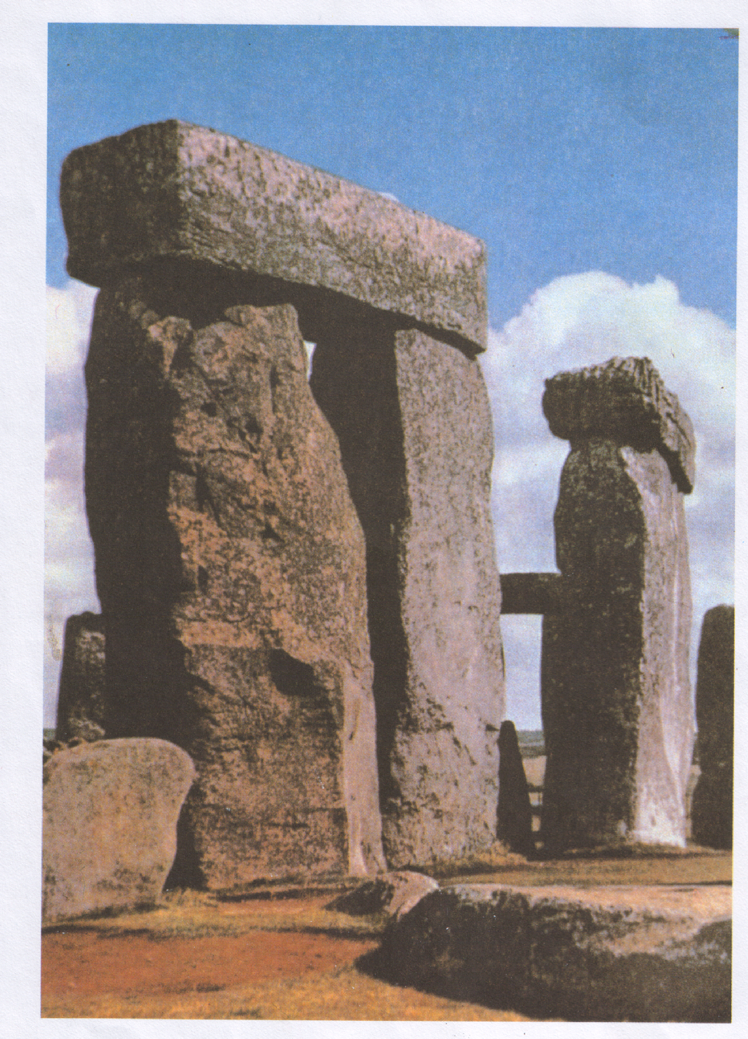
There are mountains on the territory of this country: the Grampian Mountains in Scotland, the Cambrian Mountains in Wales and the Pennine Chain in England. The highest mountain is Ben Nevis in Scotland. Its height is 1344 metres.
There are many rivers. The longest is the Severn and the deepest is the Thames. London, the capital of the U.K stands on the Thames.
Pupil₁: Of the four parts of the U. K. England is the largest, the industrial and the most densely populated part. Over 46 mln. people live here. London is situated here. Other important cities are Birmingham, Leeds, Manchester and others. Such industries as the wool industry, steel industry, shipbuilding industry are highly developed here.
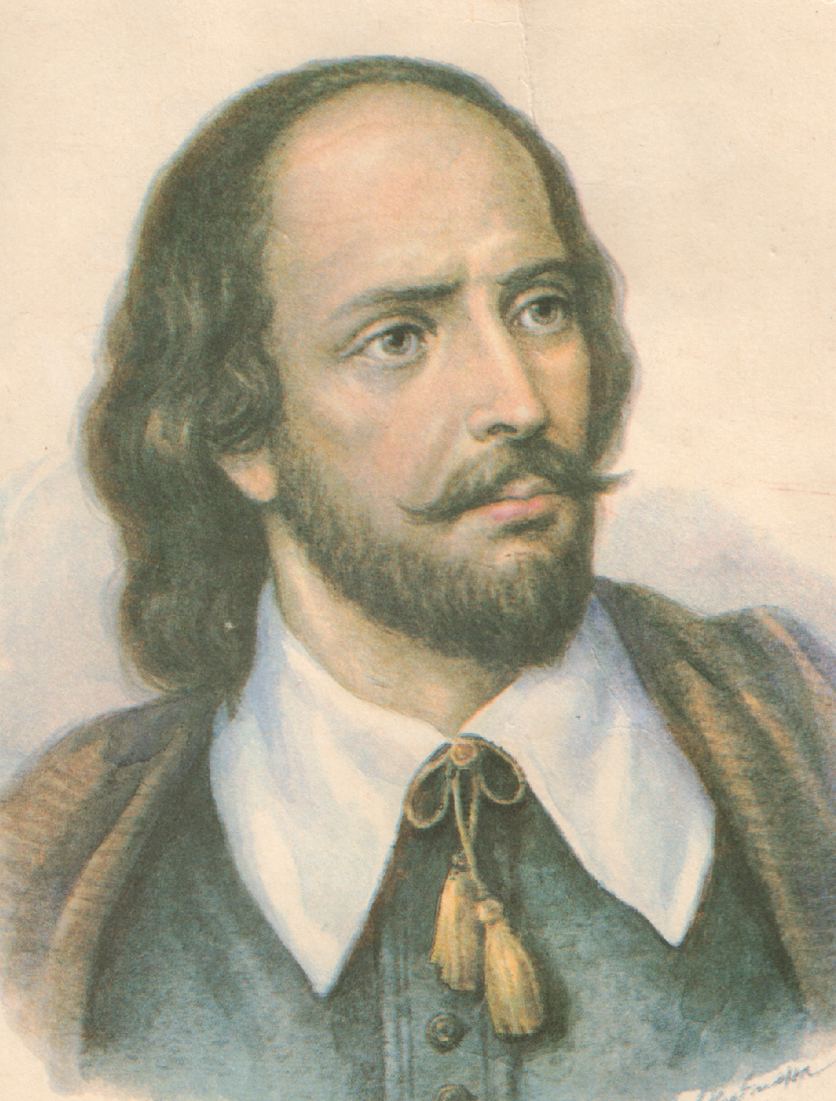
In Southern England we can see many ancient monuments and among the Stonehenge.

Teacher: In England there is a small town but it is well-known all over the world because the greatest poet, dramatist William Shakespeare was born here in 1564. What is the name of this town?
Pupil₂: The name of this town is Stratford-on Avon. In this town you can see the house where the poet was born, the Memorial to the great dramatist.

Teacher: W. Shakespeare was born and spent a great part of his life in this town. Look at these pictures of Stratford and you will learn some information about the places of this town.
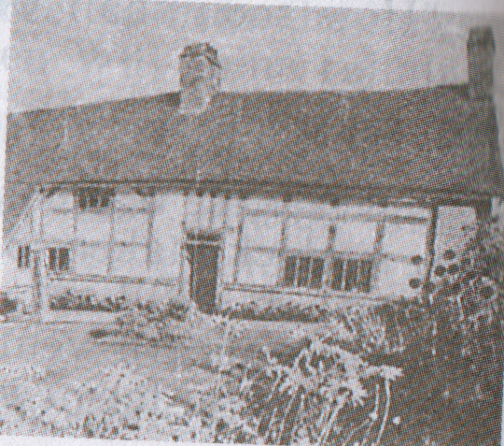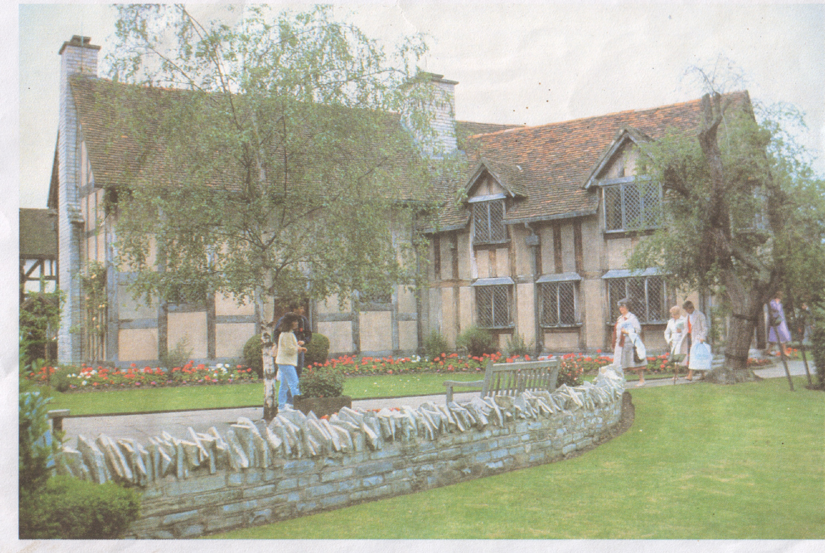

Here Shakespeare’s mother lived. It was a typical farm house of that period. | Shakespeare’s birthplace in Henley Street. William’s father lived and kept his shop in this house.

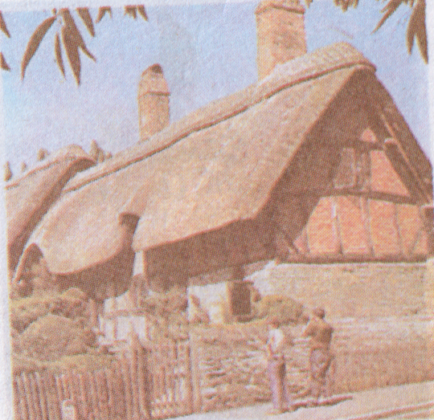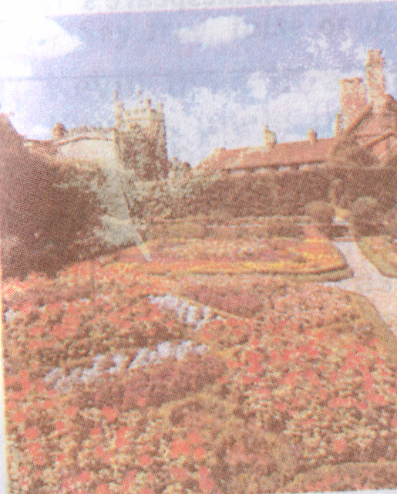
Here Anne Hathaway, Shakespeare’s wife, was born in 1556 and lived until she married William Shakespeare. | This is the place where the house in which Shakespeare died used to be. It was a big house bought by William Shakespeare for his family when he was still in London. Here he spent the last days of his life. Unfortunately the house was destroyed.

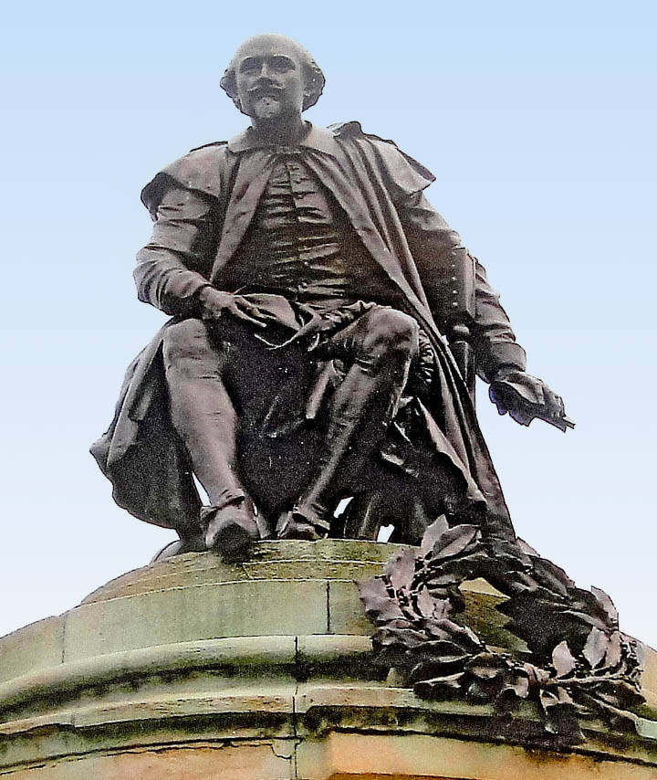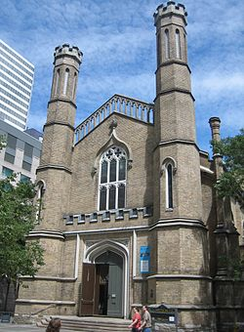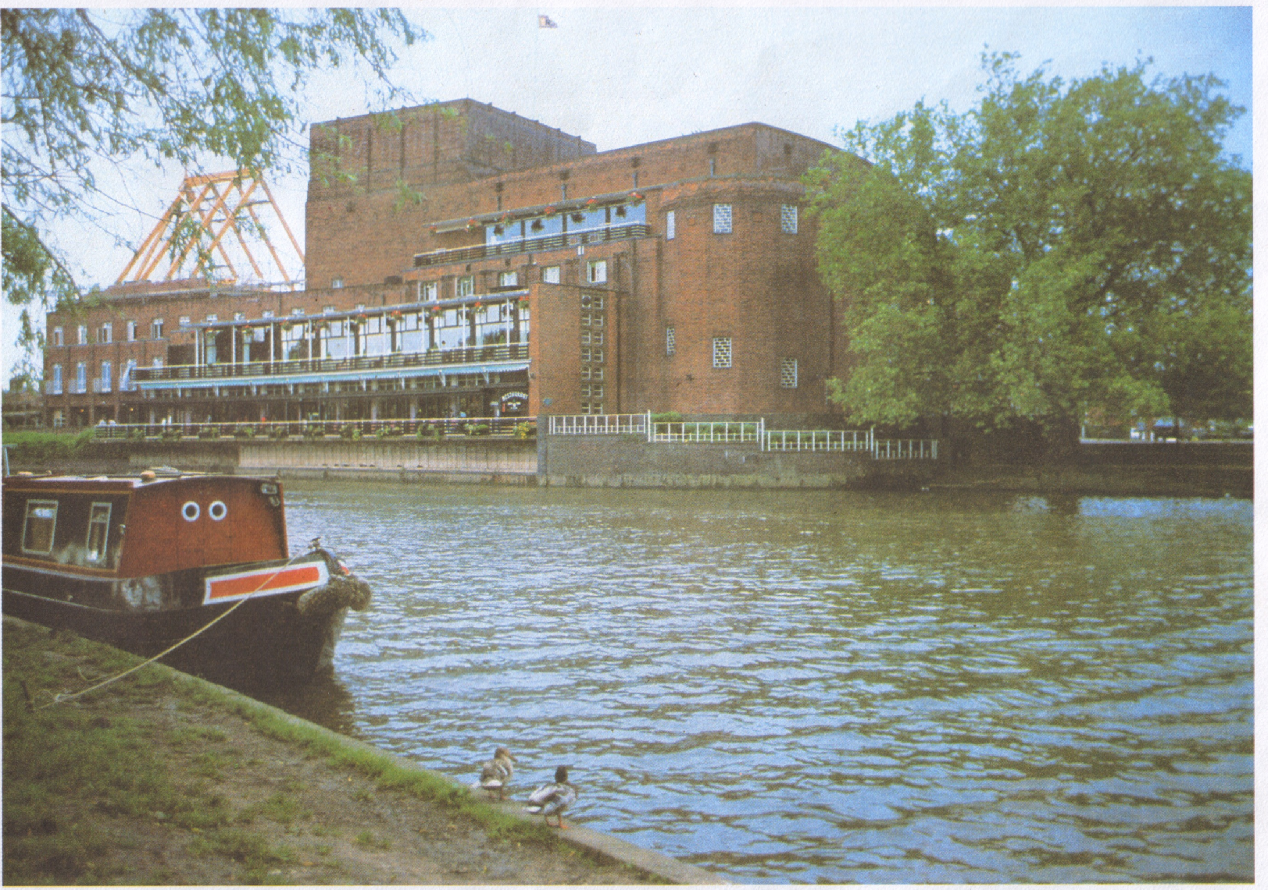
The bronze statue of Shakespeare. Shakespeare’s figure is high above the ground and on the ground there are small figures of his famous characters. | This is the Holy Trinity Church where Shakespeare was buried. Visitors admire the beauty of the church and  honour his memory. | Another memorial to Shakespeare is the Royal Shakespeare Theatre.

Teacher: Who wants to tell us about W. Shakespeare?

Pupil₃: William Shakespeare, the great English poet and dramatist, was born in 1564 in the town of Stratford-on-Avon. There were no theatres in England in those times. Groups of actors travelled from town to town showing performances in the street. Sometimes actors came to Stratford-on-Avon.
The boy went to see all their shows and liked them very much. He wanted to become an actor. Sometimes he wrote little plays and staged them with his friends.
When he was twenty-one, William went to London. There he joined a group of actors. At first he only helped actors and then began to write plays for them.
Soon Shakespeare’s plays were staged more and more often and became famous.
The theatre where he worked was called “The Globe”. It became the first professional theatre. Everyone knows Shakespeare’s plays. The most famous of them are “Othello”, “Hamlet”, “Romeo and Juliet”, “King Lear” and others. Shakespeare showed the real life and relations between people.
Shakespeare’s works will always be interesting for all people.

Listening.
Pre-listening task:
Teacher: And now we shall speak about Scotland. Try to answer my questions:
- Where is Scotland situated?
- What is its capital?
- What other cities of Scotland can you name?
- What is the national symbol of the country?
- What rivers of Scotland do you know?
- What is Edinburgh, the capital of Scotland associated with?

Now you will listen to the text about Scotland and then you will answer the questions concerning this text. Here there are some words that may be unknown for you:
Thistle – будяк
To divide – ділити
Valley – долина
Attractive – привабливий.
While-listening task.

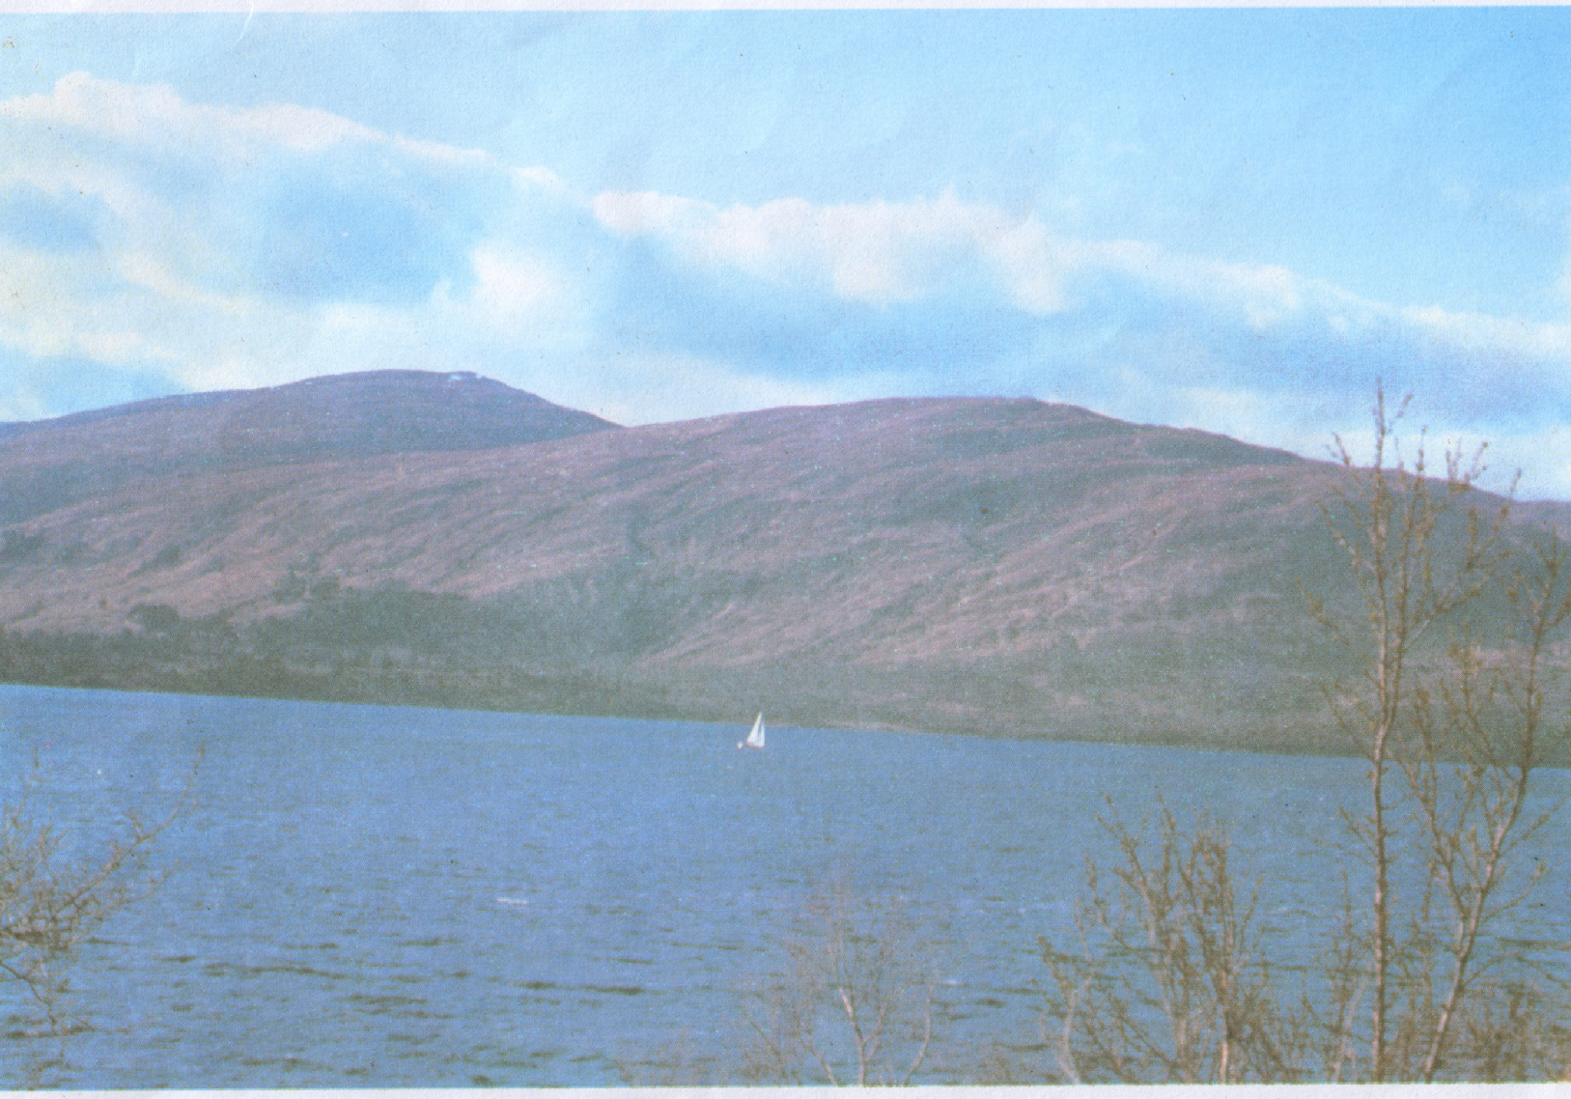
Scotland the Beautiful.
Scotland is a country in the U. K. to the north of England. It symbol is a thistle; its patron saint is St. Andrew. The country is divided into Highlands and Lowlands. Most of the industry is concentrated in Lowlands, in the Clyde Valley.
Glasgow is its largest and busiest town, Edinburgh is its capital. Glasgow and Edinburgh are the two great centres of Scotland. There is only 45 miles between them, and it will take you about an hour to get from Glasgow to Edinburgh by train but cities are very different.
Glasgow is the heart of industry. It is a centre of business and trade. It is very busy, prosperous, dirty in some parts and smart in others, it is beautiful and ugly with its large port and busy streets.
Edinburgh is rather cold and attractive, very proud but friendly and has a great past. Edinburgh is known as Athens of the North. It is an ancient city and if you walk around it you can touch on history at every step. Practically every building has a tale to tell.
Post-listening task:
Arrange the sentences into the proper order:
- Its symbol is a thistle.
- Edinburgh is known as Athens of the North.
- Scotland is a country in the U.K. to the north of England.
- Glasgow and Edinburgh are the two great centres of Scotland.
- Glasgow is the heart of industry.

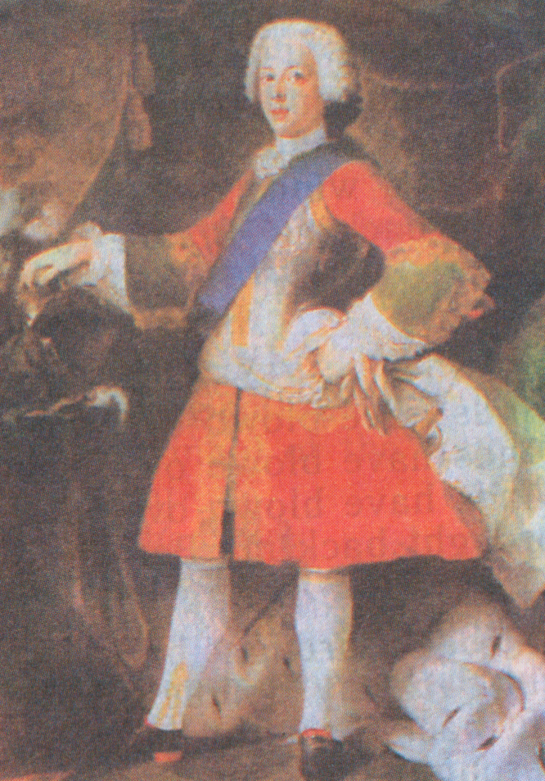
Teacher: And I want you to listen to a wonderful Scottish song “My Bonnie Is over the Ocean”. But first I would like to say some words about this song. It is a song about Prince Charles Edward Stewart who was known as Bonnie Prince Charlie because he was young and good-looking (“bonnie” means “good-looking”). He was also Scotland’s national hero who fought bravely against the English in the 18th century trying to make Scotland independent, but his army was defeated.
(Listening to the song “My Bonnie Is over the Ocean”).
Teacher: What industries are developed in Wales and Northern Ireland?
Pupil₄: Wales became a part of the U. K. in 1536. The population of Wales is about 3 mln. people. Wales is a country of old rocks. Here such industries as coal-mining, steel-production, metal industries are found. As for Northern Ireland it is the smallest part of the U.K. For a long time it was a colony of Britain. The population of Northern Ireland is about 1.5 million people. Agriculture, shipbuilding and textiles are developed here.
Teacher: And now look at some sights of Wales. You can see that the scenery here is very beautiful.

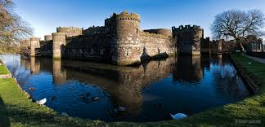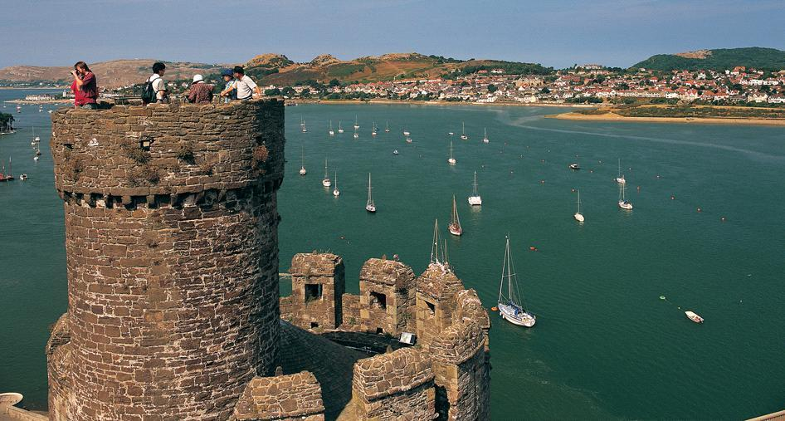

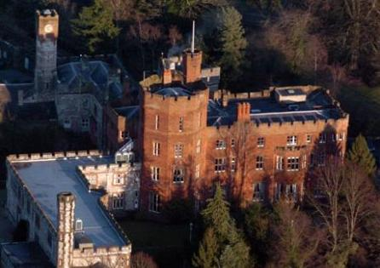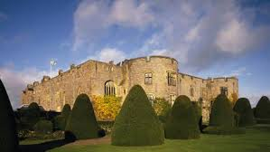

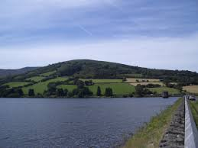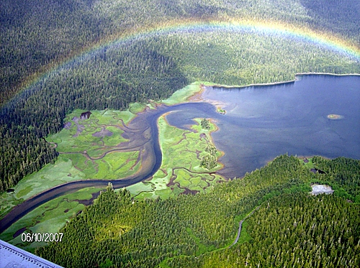

Reading.
Pre-reading task.
Teacher: The Welsh people are fond of singing, folk music, poetry. Welsh literature is one of the oldest in Europe. There are many choirs in Wales. Now there is a growing movement of revival of Welsh culture. Now you will read the text about an Eisteddfod, the festival of Welsh culture.

While-reading task.
An Eisteddfod.
Every year in August, there is a national Eisteddfod in Wales. What is Eisteddfod? It is a meeting of Welshmen interested in Welsh poetry, Welsh songs and music. One year it is in town in North Wales, the next year it is in town in South Wales. It lasts for a week.

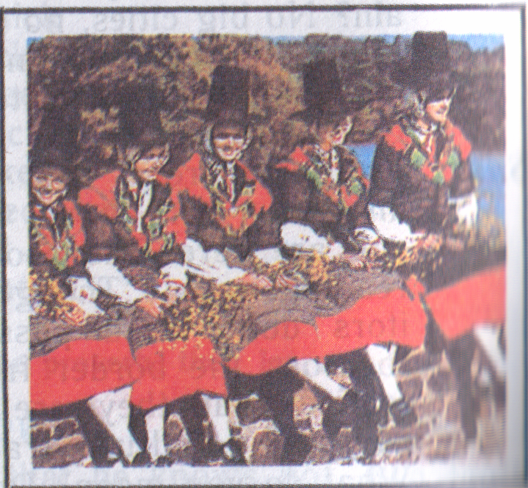
Between 10,000 and 15,000 people come to an Eisteddfod every day. Some want to listen to the poems; some want to listen to the singing; and some want just to meet their friends and talk in Welsh. The Welsh people from many countries come back to Wales for the National Eisteddfod. You won’t hear much English at an Eisteddfod.
There are competitions at an Eisteddfod, too; for the best Welsh poem and song; and for the best singers. The competitions are organized by the Druids. The Druids wear long clothes; their leader is always a poet.
About a hundred years ago, some Welsh people became very interested in the old traditions and ceremonies at the Eisteddfod.
Welsh traditions are very old, and the Welsh people are very proud of them.

Post-reading task.
(Work with computers).

Test I:
State whether the following statements are true or false:

  - An Eisteddfod is a National Sport Competition.
  - One year it is in a town in England.
  - The next year it is in a town in South Wales.
  - Some want to listen to the singing, some want to listen to the speaker.
  - English people from many countries come back to Wales for the National Eisteddfod.

Test II:
Complete the quiz.

- What is an Eisteddfod?
- a city; b) a meeting; c) a part of Britain.
- Where does an Eisteddfod take place?
- in London; b) in Scotland; c) in Wales.
- How long does it last?
- two days; b) for a week; c) three months.
- Who organizes an Eisteddfod?
- the Druids; b) the composers; c) the singers.
- Who is the leader of the Druids?
a) a musician; b) a singer; c) a poet.

Teacher: In the U.K. there are many large cities but London is one of the most beautiful. There are many places of interest in this city. You can see some of them looking at the map of London.

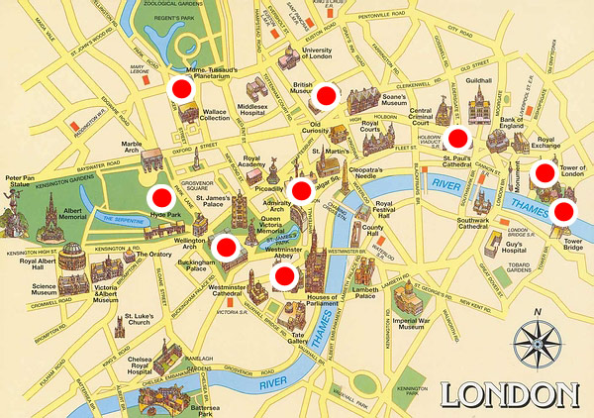

And now I want you to look at some places of interest of London.
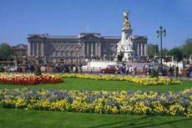 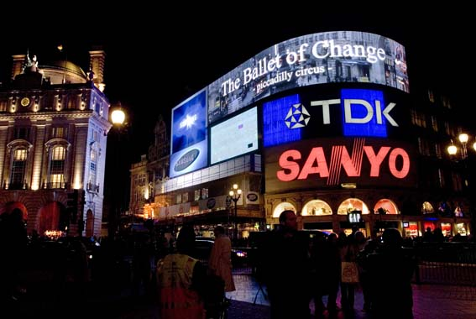 Buckingham Palace. Piccadilly Circus 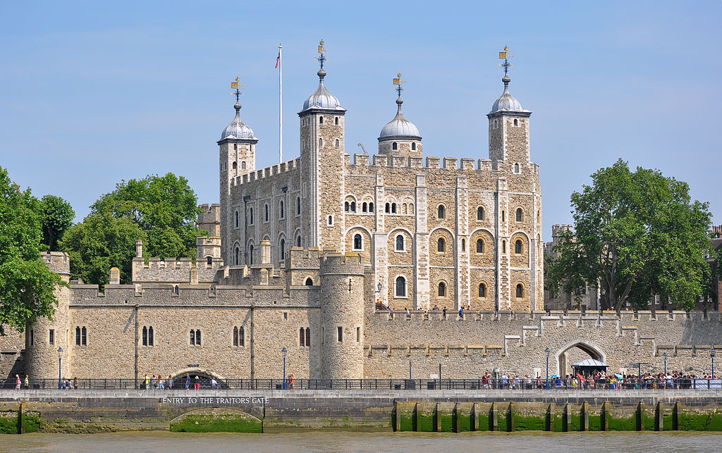 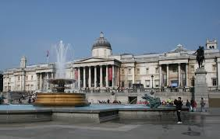
The Tower The National Gallery
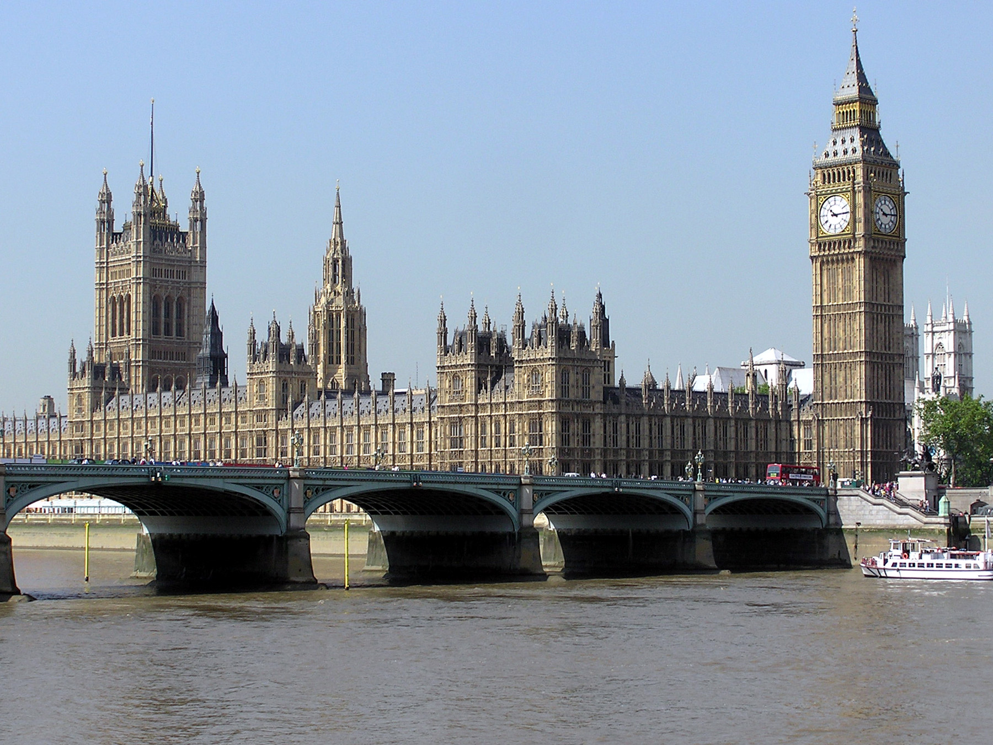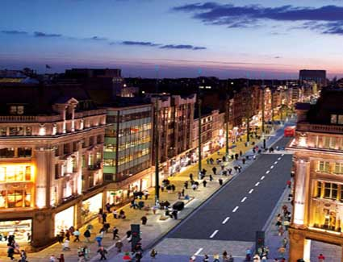
The Houses of Parliament Oxford Street
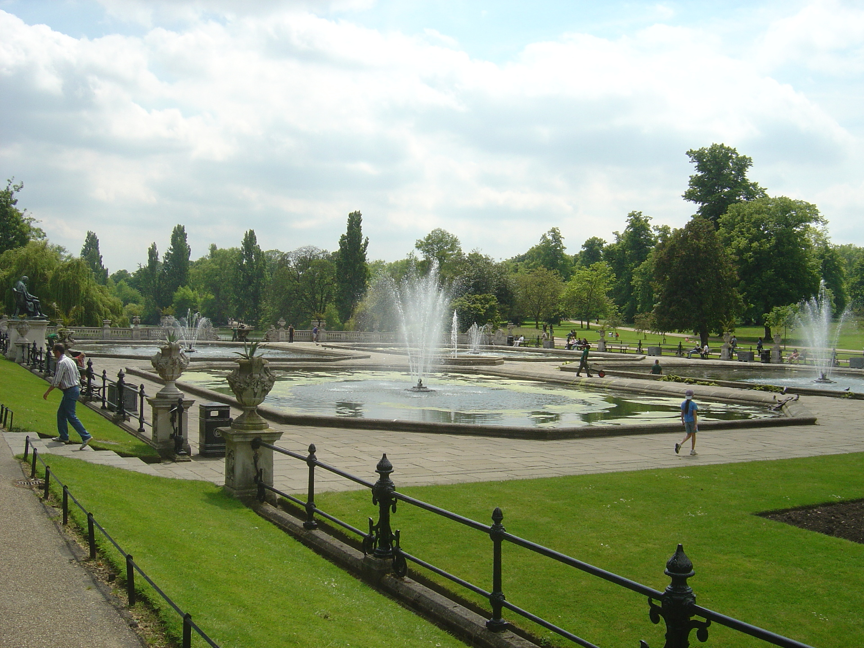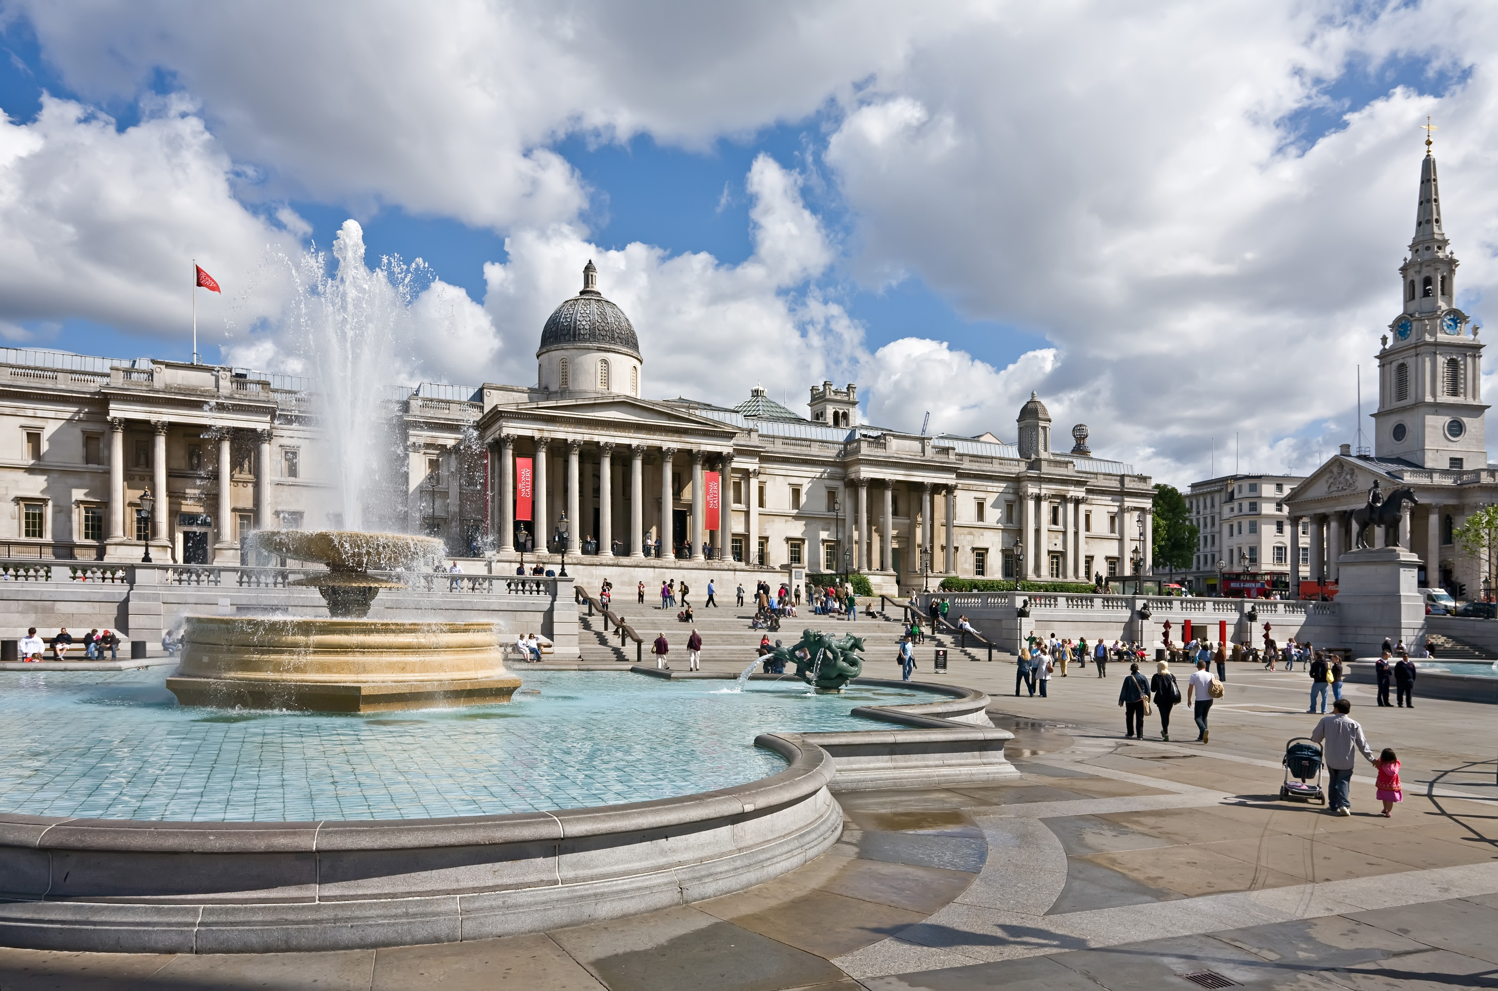
Hyde Park Trafalgar Square

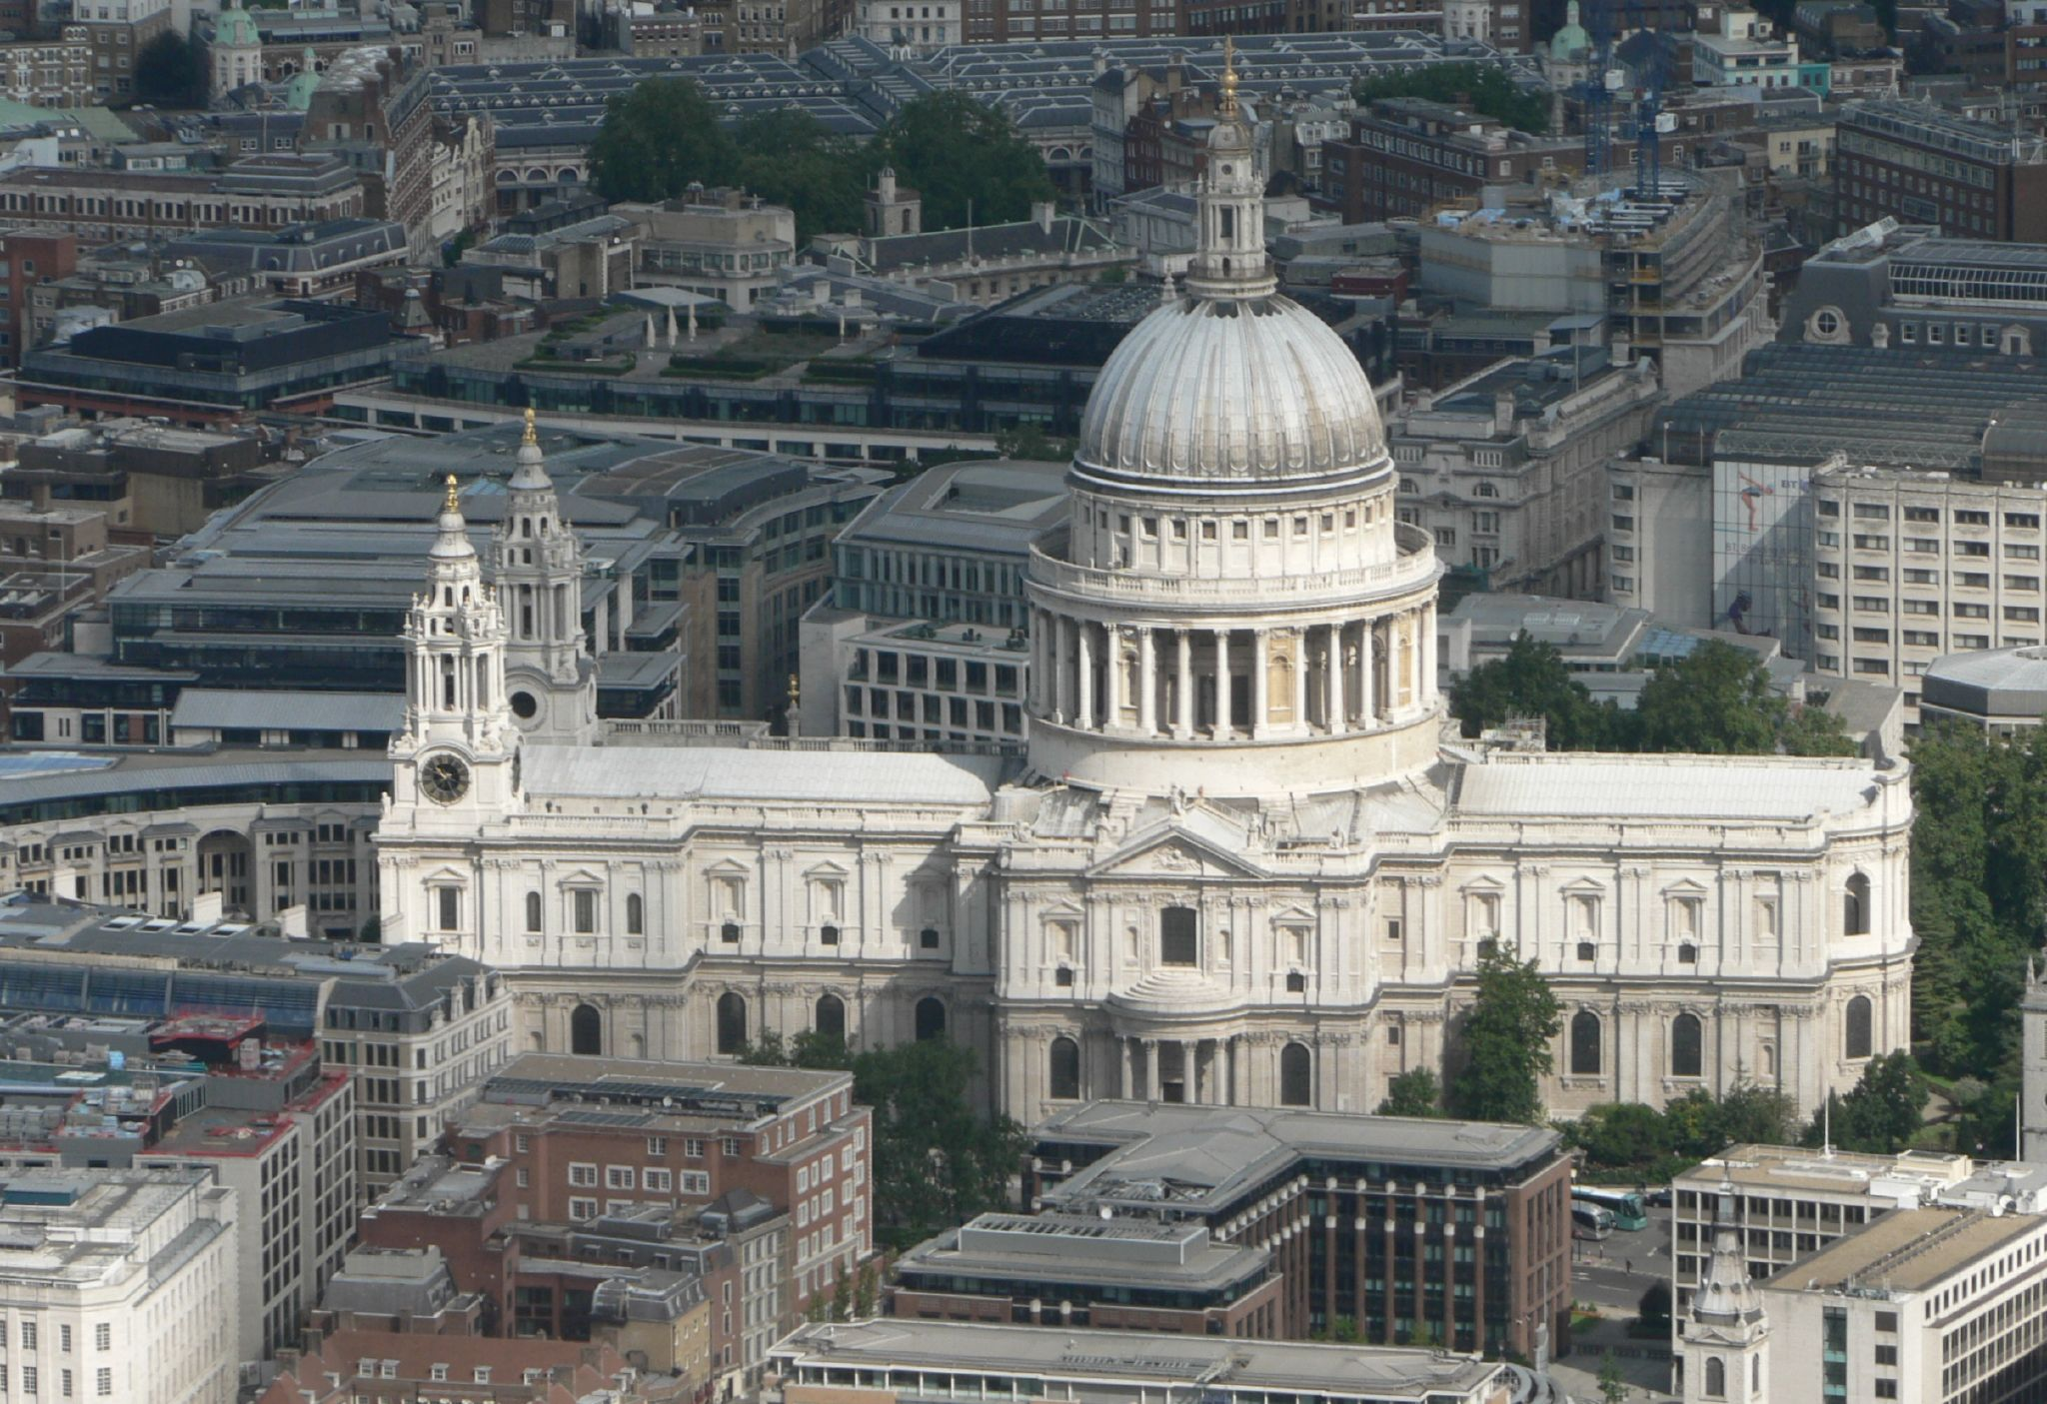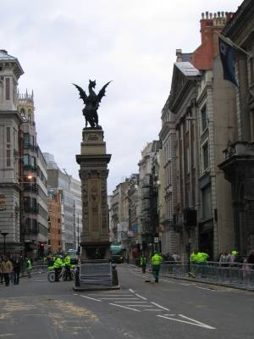
St. Paul’s Cathedral Fleet Street, London.
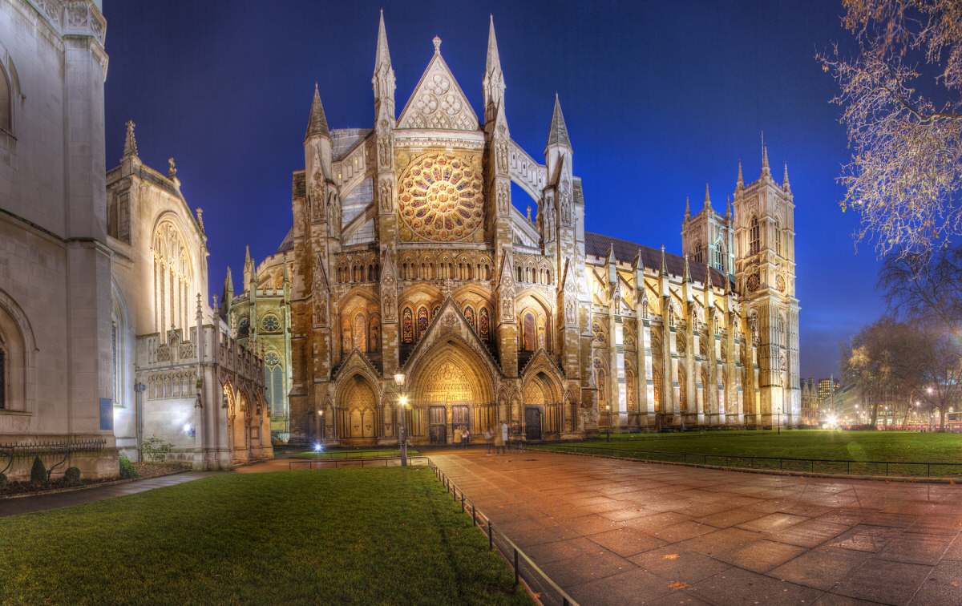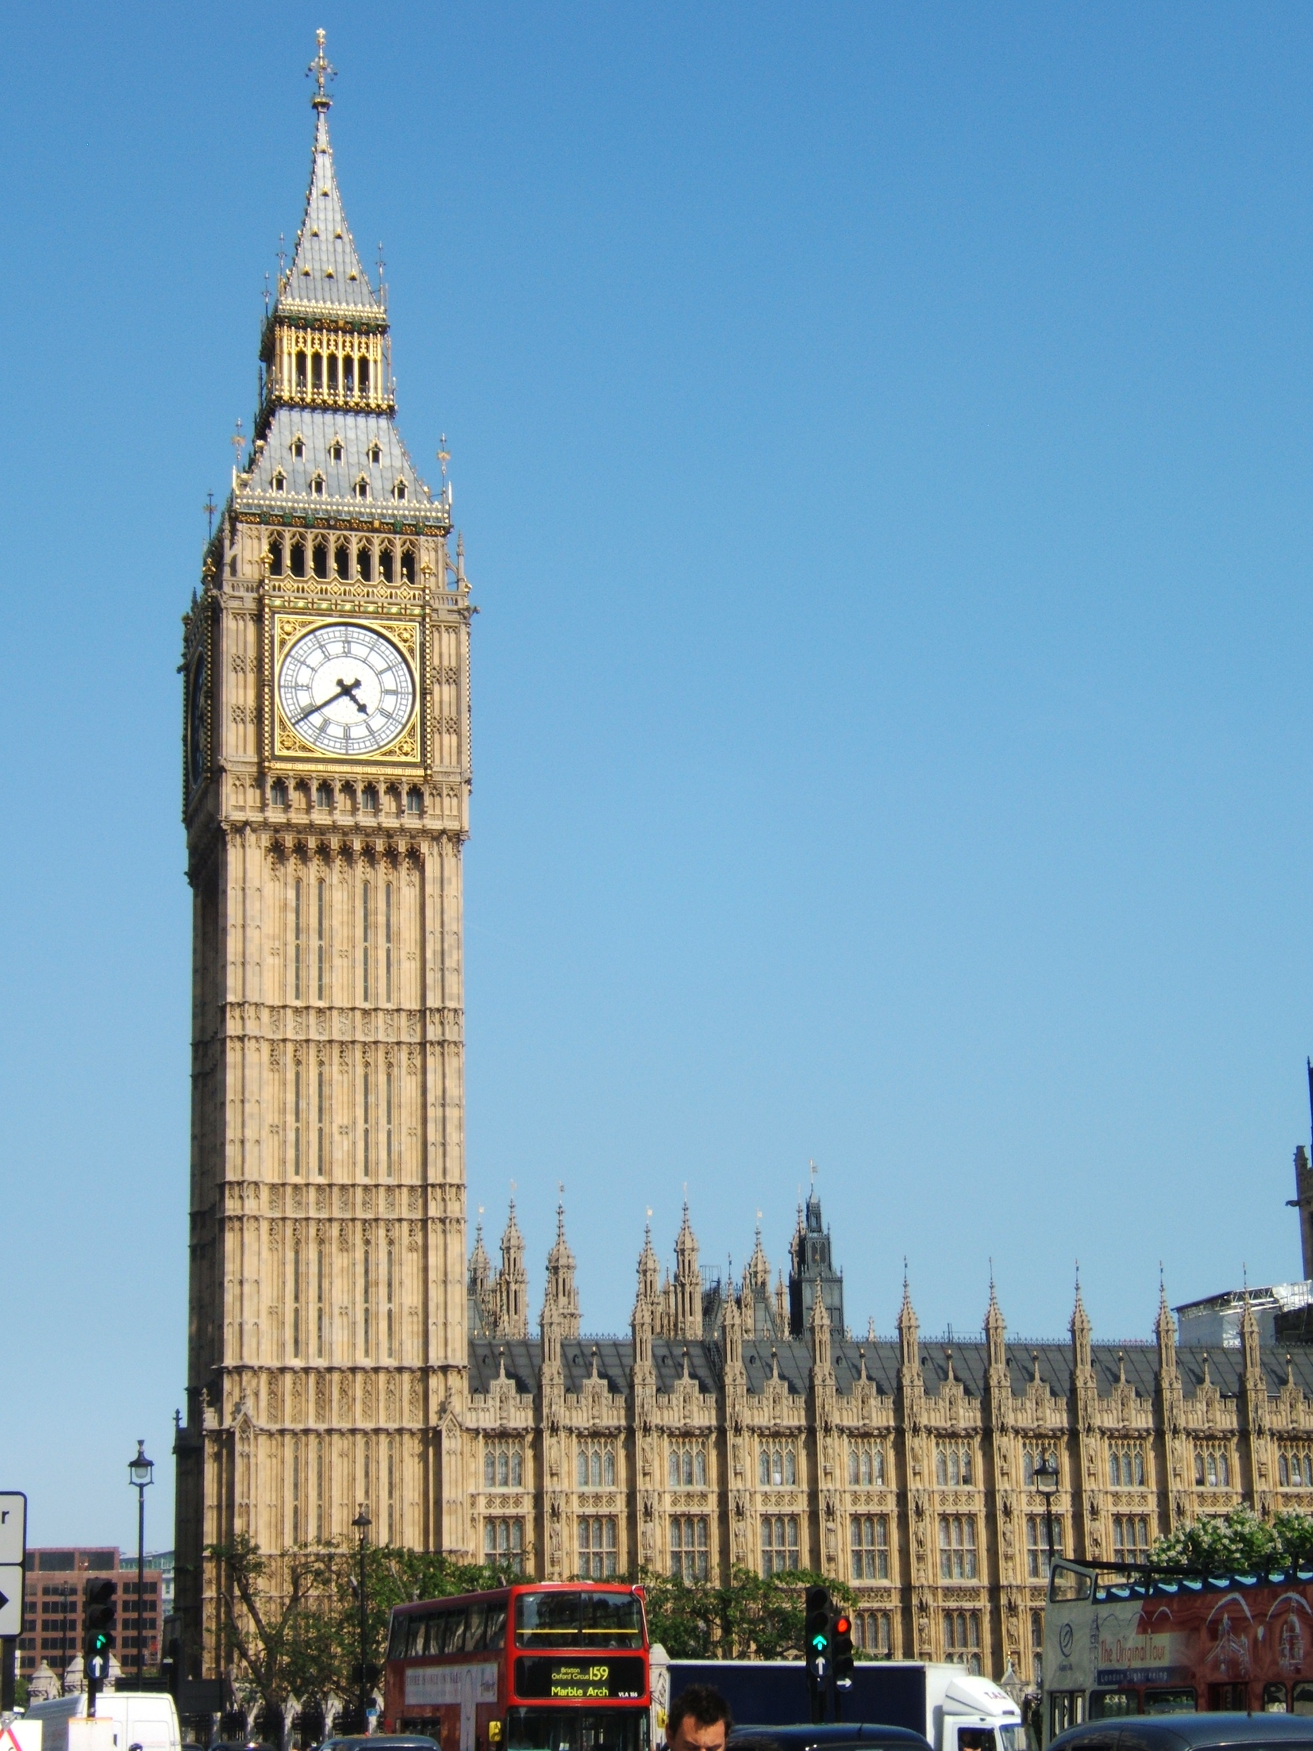

Westminster Abbey is one of the most famous English churches. Here there is the Poet’s Corner where famous poets and writers are buried. | Big Ben is the name of the clock and the bell of the clock tower of the Houses of Parliament.

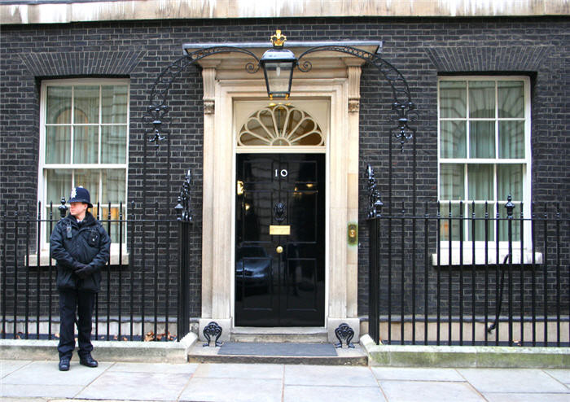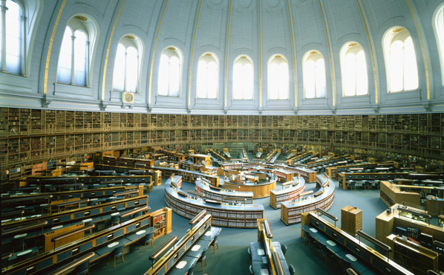
Downing Street is a small street where
the British Prime Minister lives A reading-room in the British
Museum Library

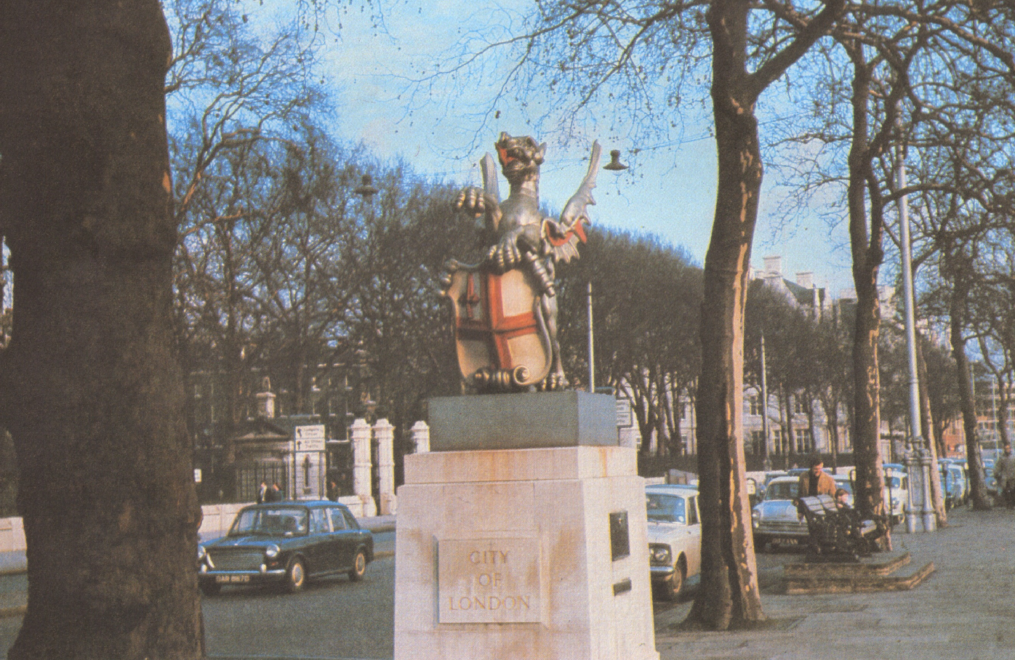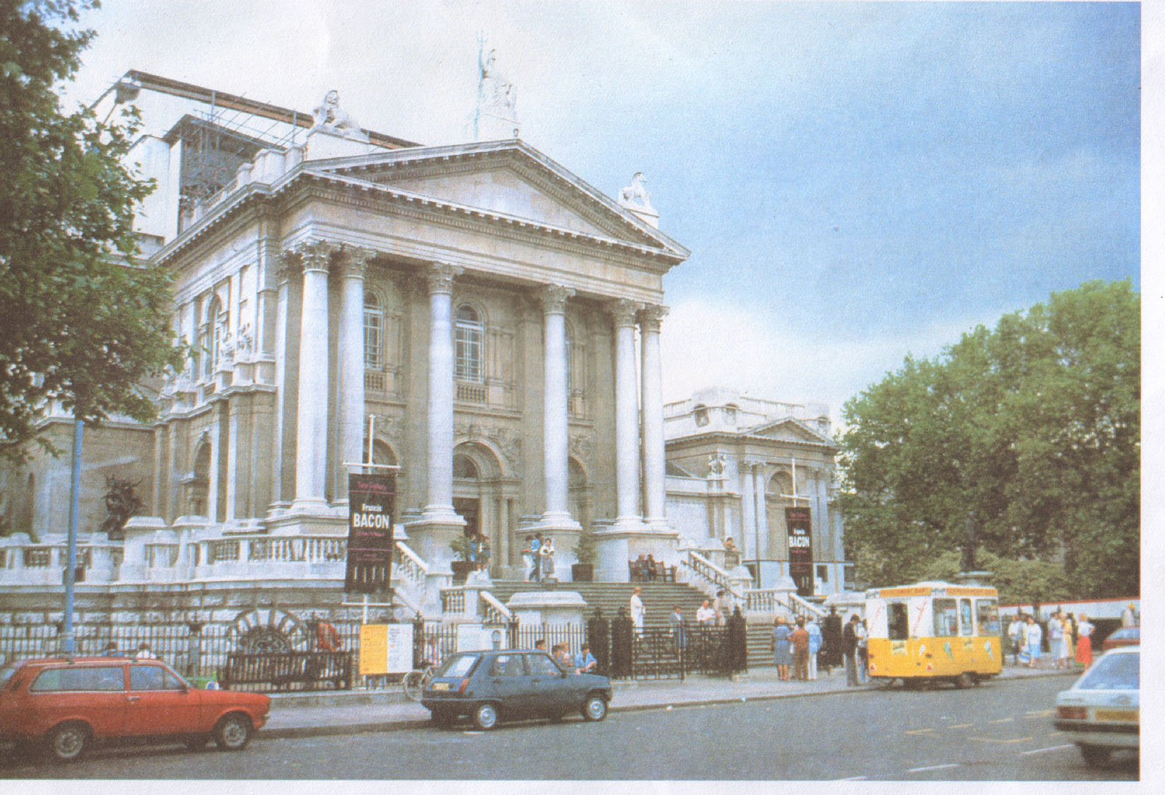
The symbol of the City, London’s business
centre. The Tate Gallery.

Writing.

(Work on computers).

Teacher: And now we shall revise the Past Perfect Tense.
In these sentences select the tense form (Past Perfect/Past Simple) that completes it correctly. There are five sentences.
  - I (woke up/had woken up) early and got out of bed.
  - I got out of bed an hour later I (woke up/had woken up).
  - We were late. The meeting (started/had started) an hour before.

  - She was the most delightful person I (ever met/had ever met).
  - That morning she went out after she (phoned/had phoned) somebody.

Summary of the lesson.
Home Assignment.

Eisteddfod – Айстедвод – (змагання валійських співаків, музикантів, поетів)
Druid – друїд, розпорядник на Айстедводі.

